FLOATING BAMBOO HOUSES FOR CLIMATE REFUGEES

Vishal Sharma (L30085817)

https://github.com/Rishi1439/Database-system-.git

Windows

***Description:***

The Climate Refugees, also known as Floating Bamboo Houses, It is a firm that designs, produces, and sells floating bamboo houses for individuals who have been displaced due to climate change. Our homes are constructed using a range of materials, including bamboo, recycled plastic, and solar panels. They are made to be sturdy, long-lasting, and environmental friendly.

Floating Bamboo dwellings for Climate Refugees employs cutting-edge technology to design and manufacture floating bamboo dwellings that are both sustainable and inexpensive. Our homes are outfitted with a variety of features, including as rainwater collection systems, solar-powered desalination systems, and vertical gardens.

Floating Bamboo Houses for Climate Refugees, I believe, are a sustainable and economical housing alternative for climate refugees. I’m thrilled to offer our customers a safe and comfortable place to live, as well as the resources they require to rebuild their lives.

***Company size estimate:***

• Number of people: 10-15

There are two locations (one headquarters and one manufacturing site).

1. Miami (Headquarters)
2. Florida (Manufacturing unit)

***Suppliers***

Raw Materials

1. Bamboo: sourced from Southeast Asia's sustainable bamboo forests
2. Recycled plastic: Available from a number of vendors, including Waste Management and Republic Services.
3. Solar panels: Available from a range of manufacturers, including Tesla and LG Solar.

***Vendors:***

1. Bamboo: Bamboo Eco and Moso Bamboo Products
2. Plastic recycling: Waste Management, Republic Services
3. Solar panels: Tesla, LG Solar

***Operational cities:***

1. Miami
2. Florida
3. Jakarta
4. Indonesia

**Network Components**

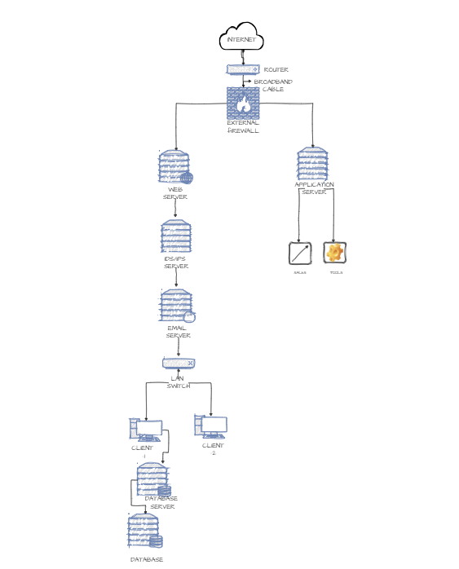<file:///C:/Users/Vishal%20Sharma/OneDrive/Desktop/Network%20Components%20week%20-1..html>

Tiers:

• External Tier: Web Server

• Internal Tier: Application Server, Email Server, Employee Server, LAN Switch, Client 1,

Client 2, Database Server, Database

Connections:

1. The External Firewall is linked to the Internet and the Web Server.
2. The IDS/IPS Server communicates with the External Firewall and all components of the Internal Tier.
3. The Web Server establishes a connection with the IDS/IPS Server.
4. The Application Server establishes a connection with the IDS/IPS Server.
5. The Email Server establishes a connection with the IDS/IPS Server.
6. The Employee Server establishes a connection with the IDS/IPS Server.
7. The LAN Switch is linked to the IDS/IPS Server, Client 1 and Client 2.
8. Client 1 joins the LAN Switch.
9. Client 2 joins the LAN Switch.
10. The Database Server establishes a connection with the IDS/IPS Server.
11. The Database establishes a connection to the Database Server.